**EXPERIMENT NUMBER 4**

| Name of Student: Sangeet Agrawal | PRN: 21070122140 | Section: CS-B |
| --- | --- | --- |

**Title:** Basic cryptography - Caesar cipher and substitution ciphers using an open source tool Cryptool.

**Aim:** Study, understand and demonstrate stream cipher encryption decryption algorithms

**Objective:** To make students understand and demonstrate various stream cipher encryption algorithms.

**Theory:**

**Caesar Cipher [Source: Cryptography and Network Security by Stallings]**

The earliest known use of a substitution cipher, and the simplest, was by Julius Caesar. The Caesar cipher involves replacing each letter of the alphabet with the letter standing three places further down the alphabet. For example,

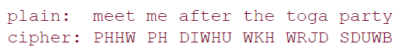

Note that the alphabet is wrapped around, so that the letter following Z is A. We can define the transformation by listing all possibilities, as follows:



**About cryptool [Source: Website link 1]:** It is a free tool available on CrypTool Portal. The CrypTool Portal (CTP) is the starting page of the CrypTool project. Its aim is to raise awareness and interest in crypto techniques for everyone. The CT project develops the world's most-widespread free e-learning programs in the area of cryptography and cryptanalysis. All learning programs in the CT project are open source and available for free.

CrypTool-Online (CTO for short) is a platform with various applications (called plugins) for testing, learning and discovering old and modern cryptography.

**Tools to be practiced:**

1. [Cryptool Website](https://www.cryptool.org/en/)
2. [Cryptii Website](https://cryptii.com)
3. [Online Cryptography Tools Website](https://www.onlinecryptographytools.com)
4. [Assignment from Cryptography Virtual Lab](https://cse29-iiith.vlabs.ac.in/) (website link 6)

**Reference web links:**

1. <https://www.cryptool.org/en/>
2. <https://www.axcrypt.net>
3. <https://docs.microsoft.com>
4. <https://www.belightsoft.com>
5. <https://www.jetico.com>
6. <https://cse29-iiith.vlabs.ac.in/>

**Conclusion:** In this experiment, we explored basic cryptography, focusing on the Caesar Cipher and substitution ciphers using CrypTool. This hands-on approach helped us understand and apply stream cipher algorithms effectively.

**Implementation question:**

1. Demonstrate use of cryptool with different algorithms. (at least 3)

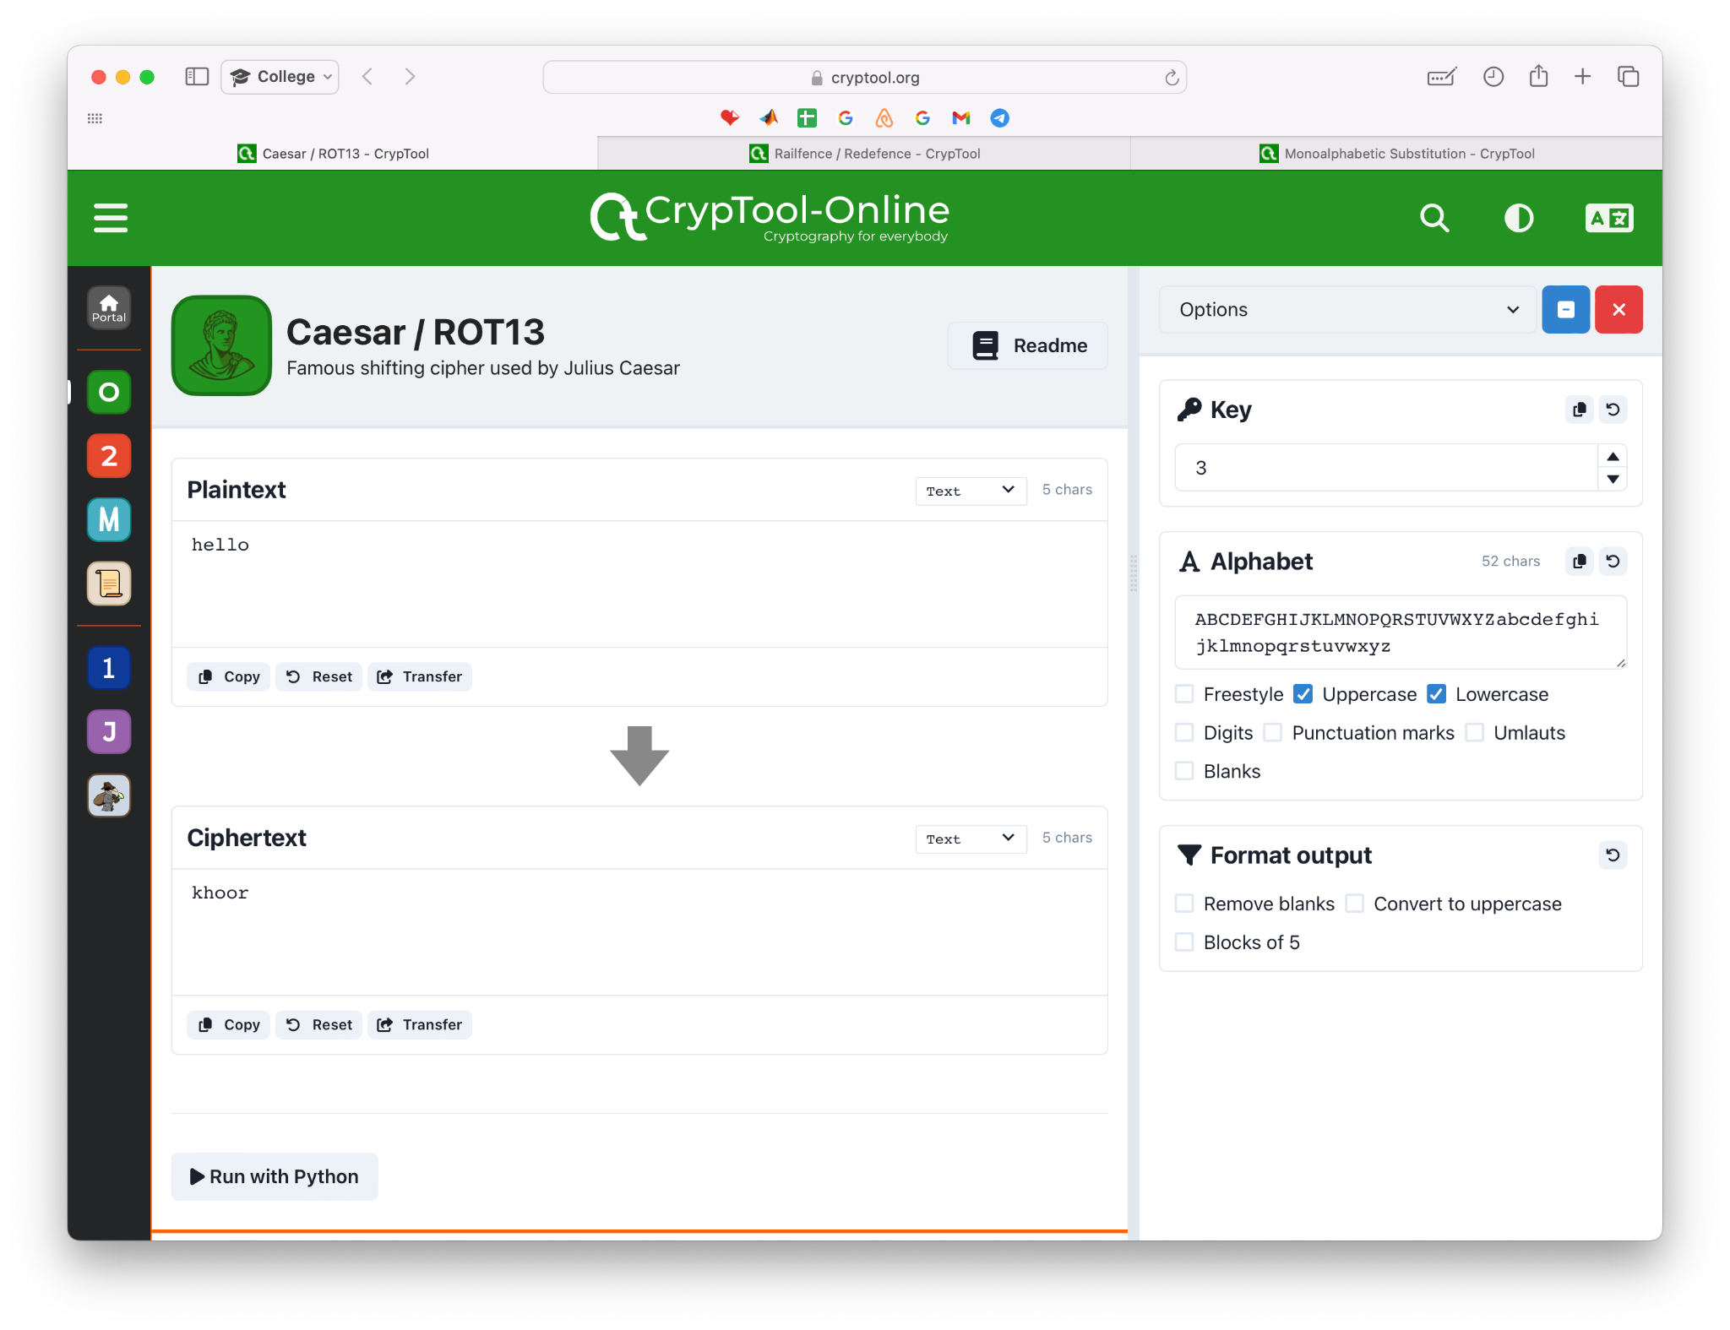

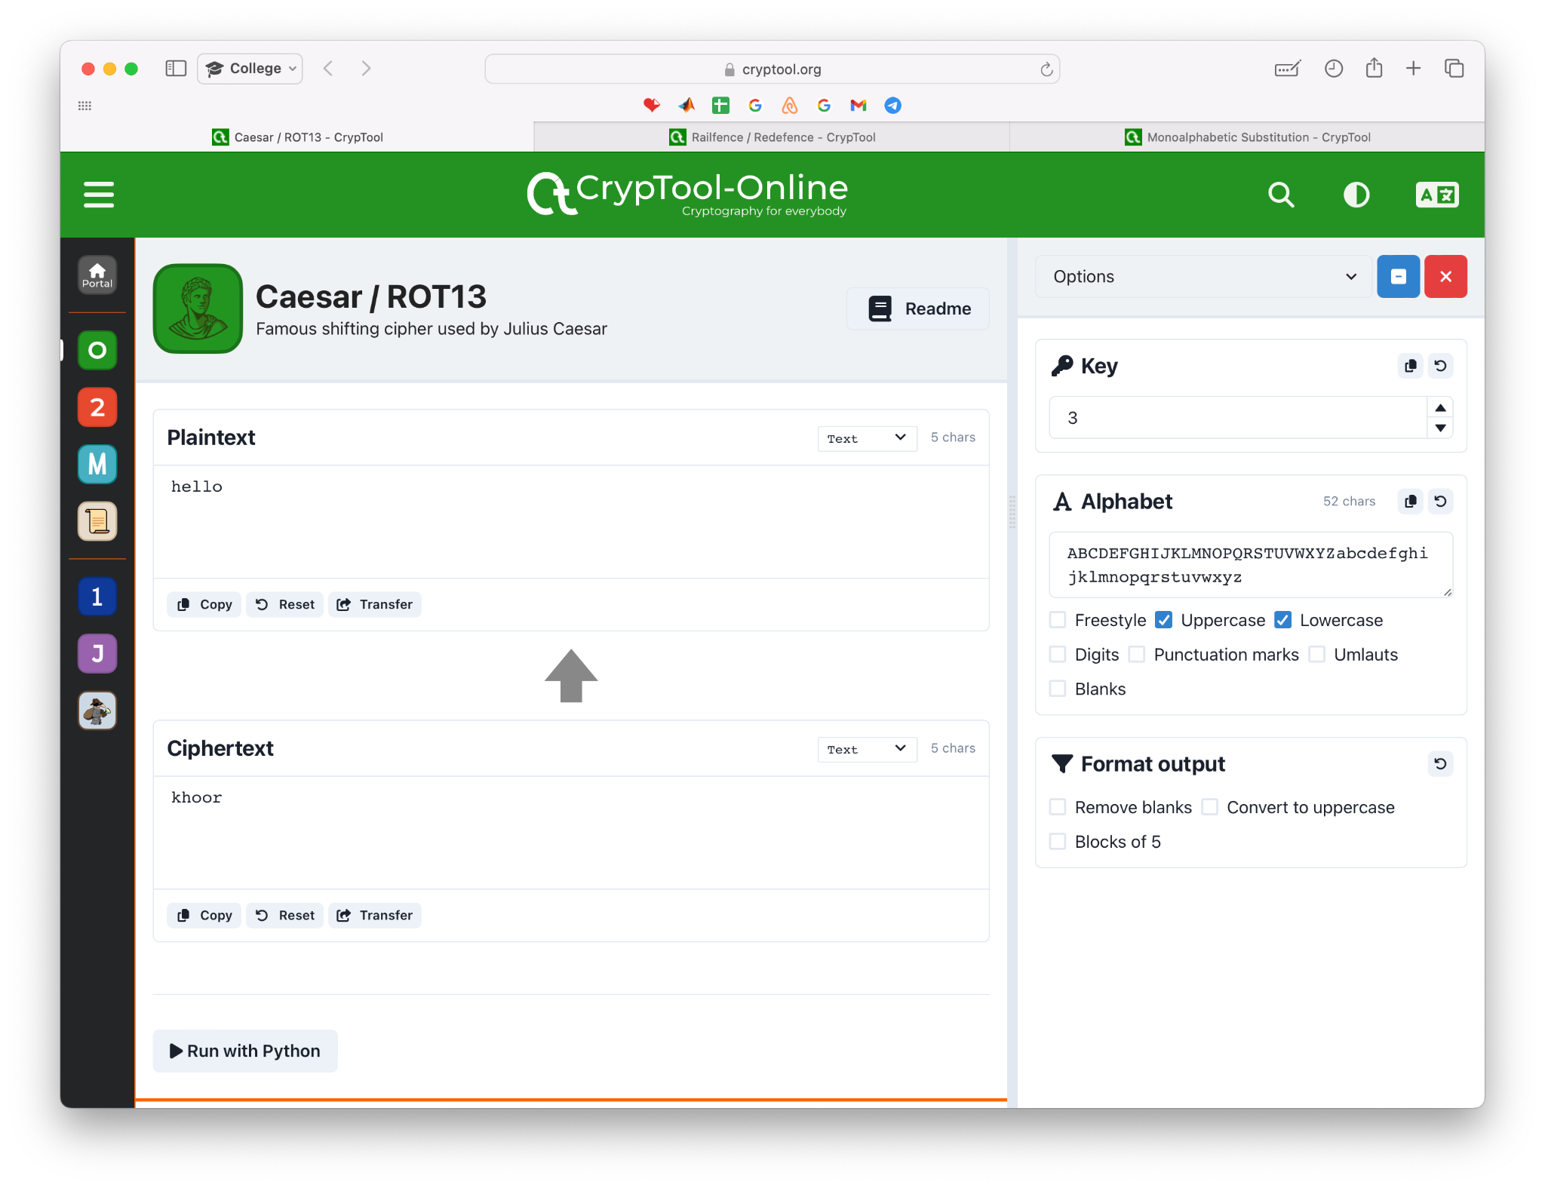

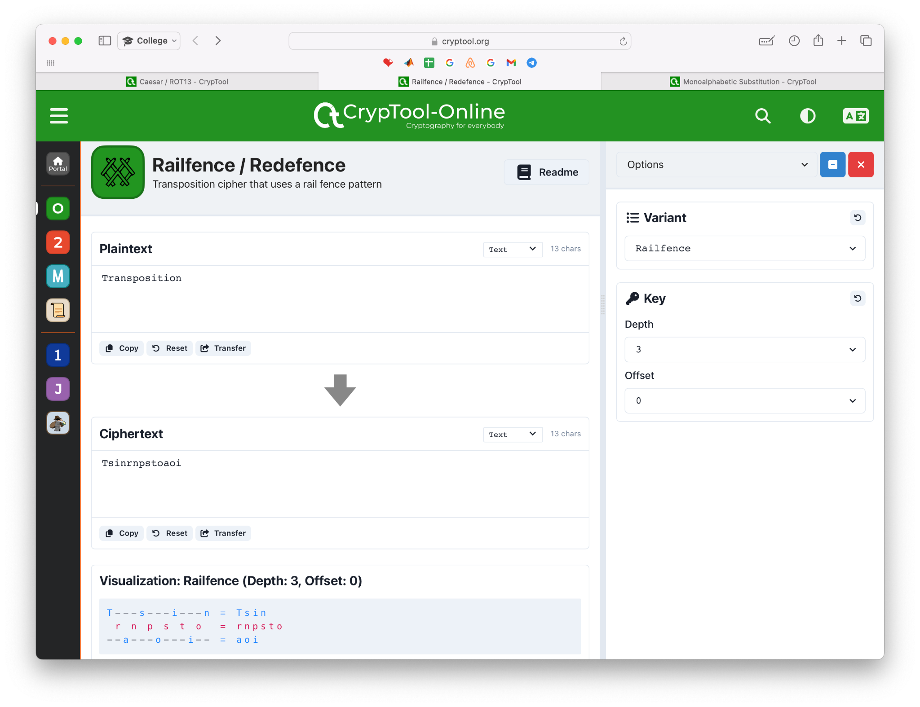

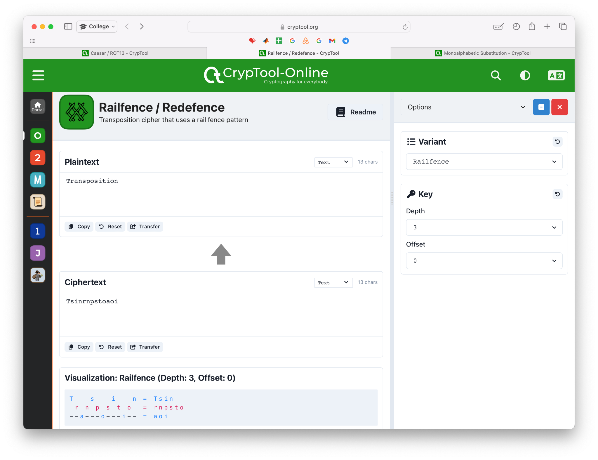

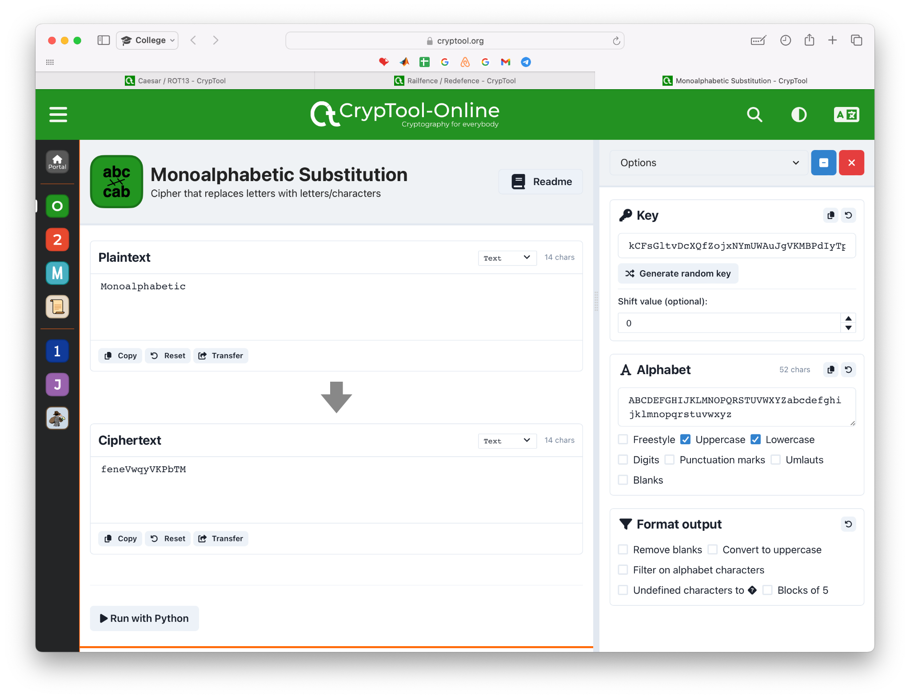

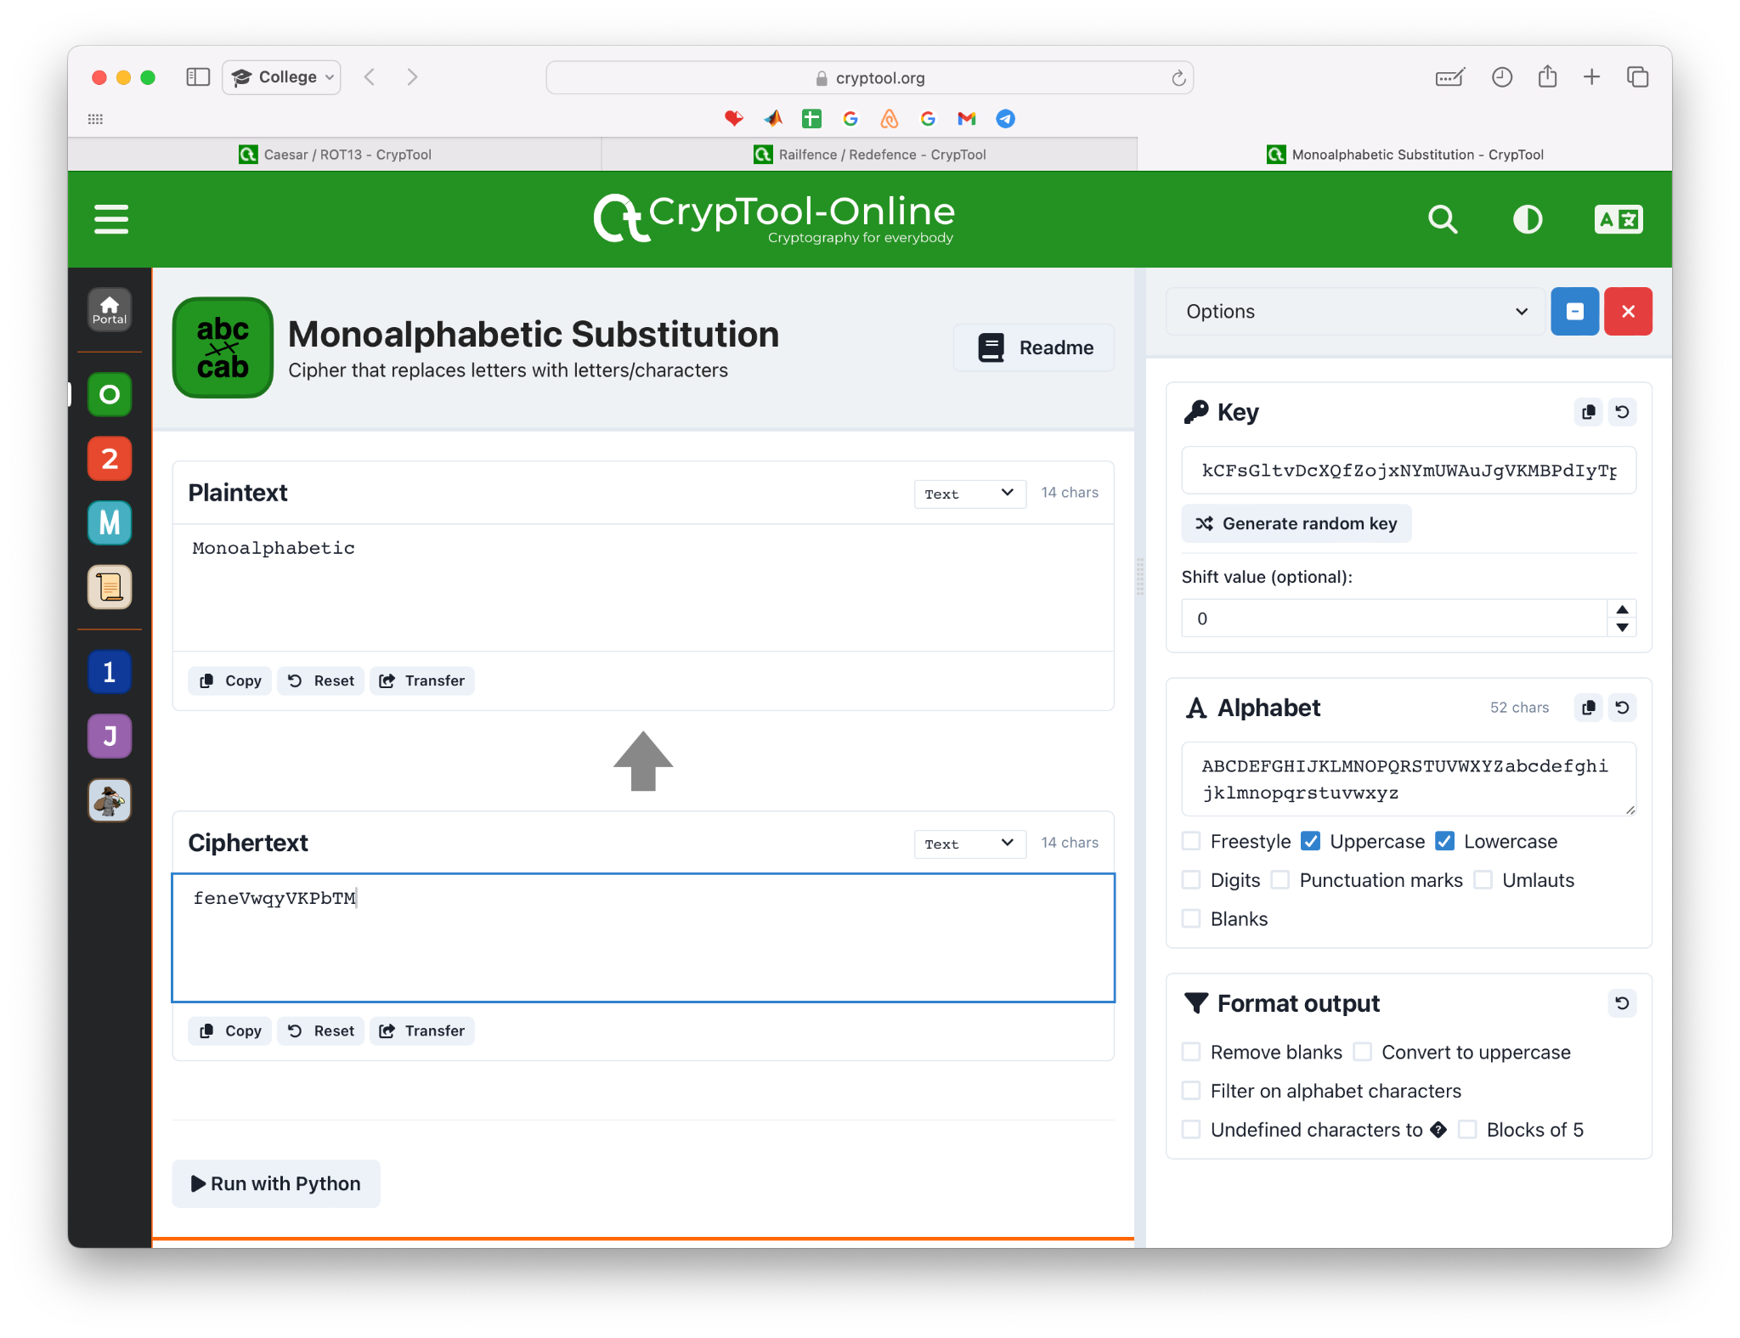

1. Demonstrate any other two free cryptography tools based on stream cipher algorithm

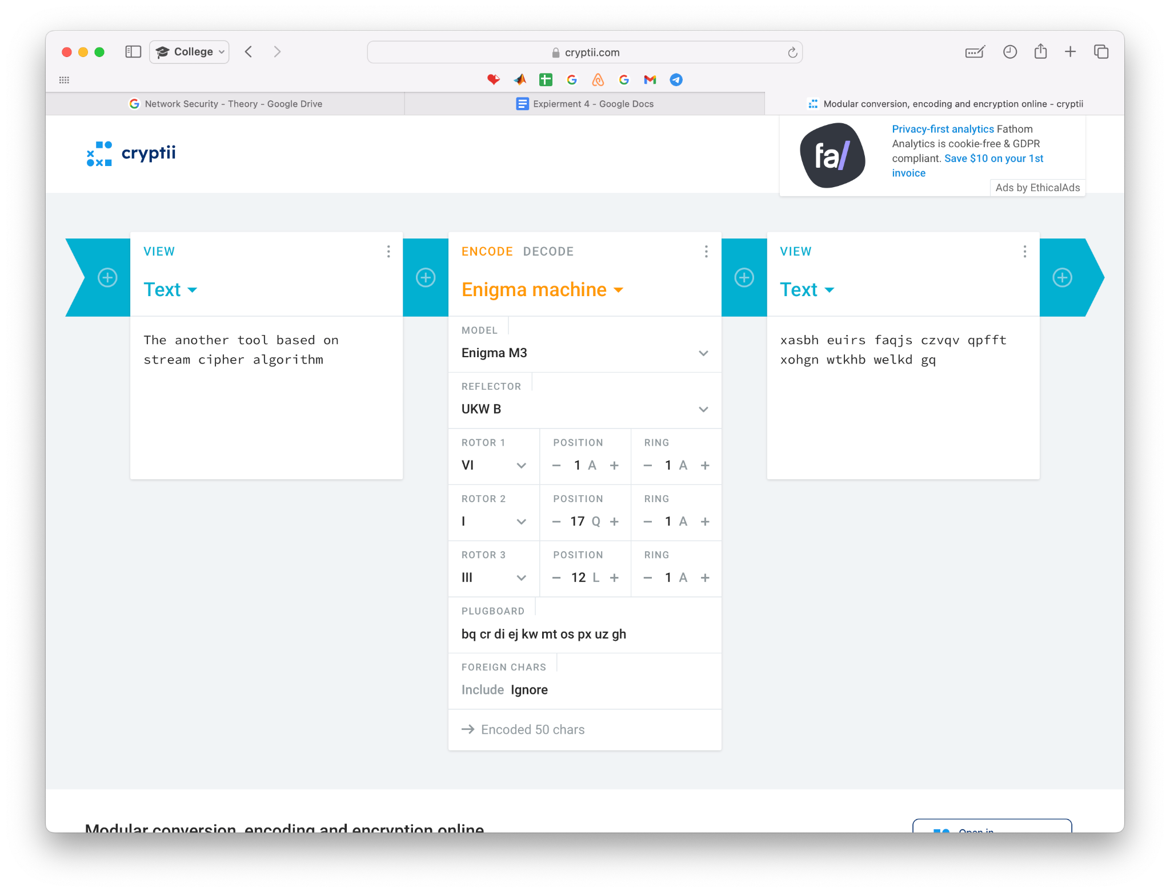

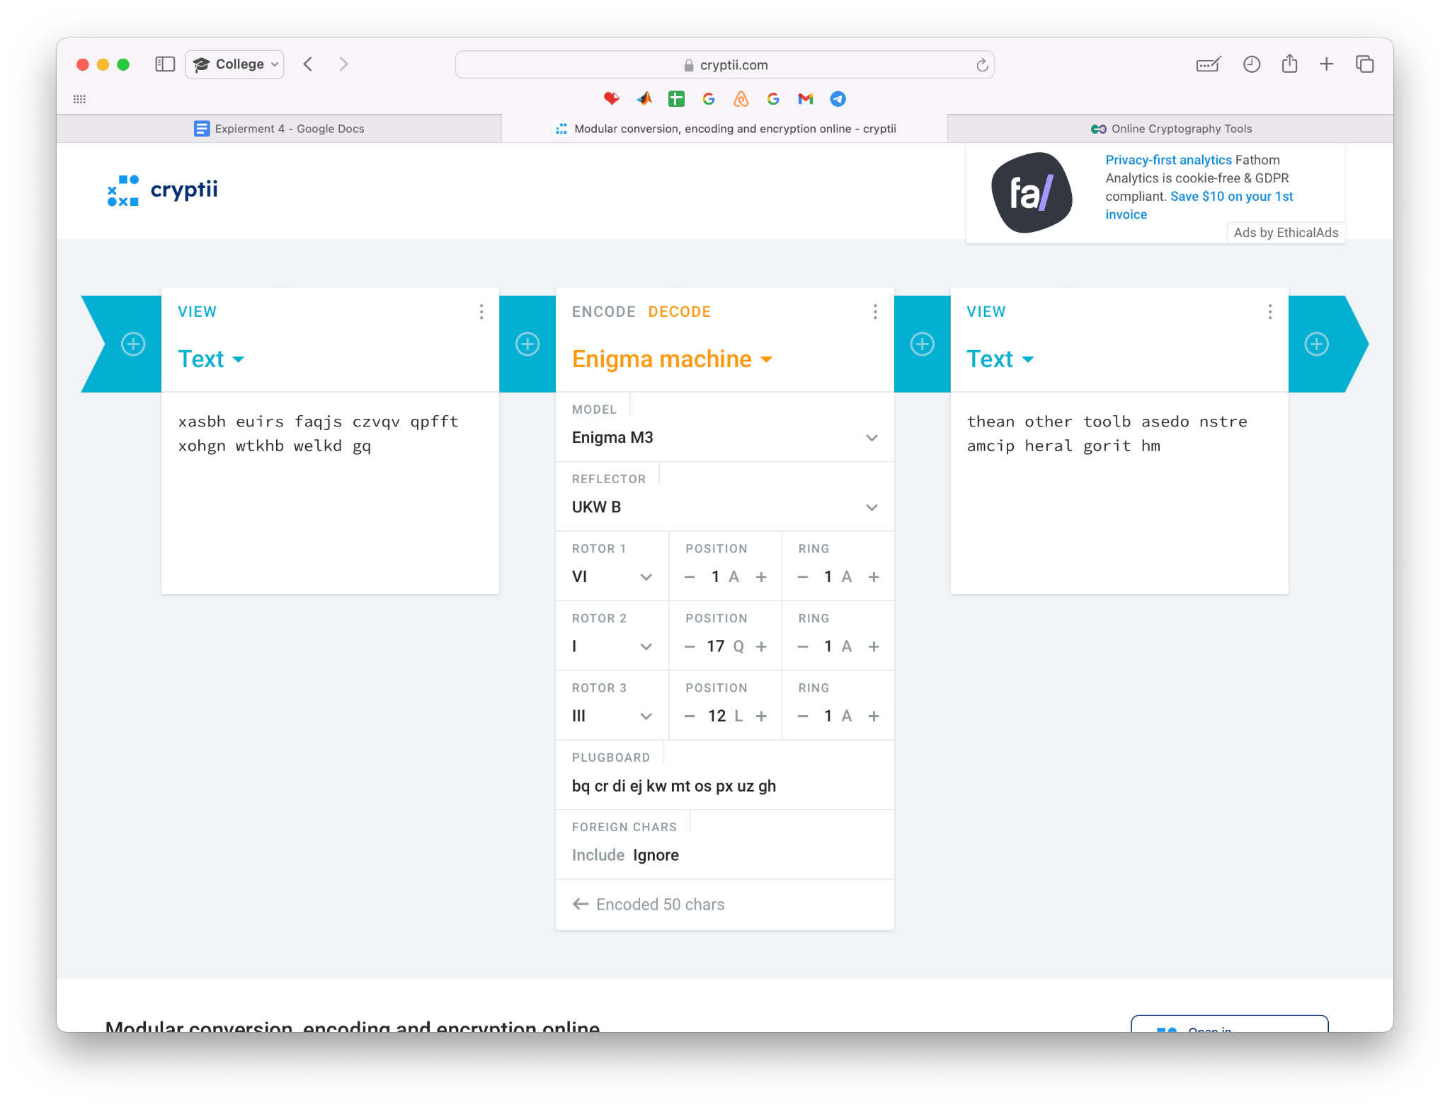

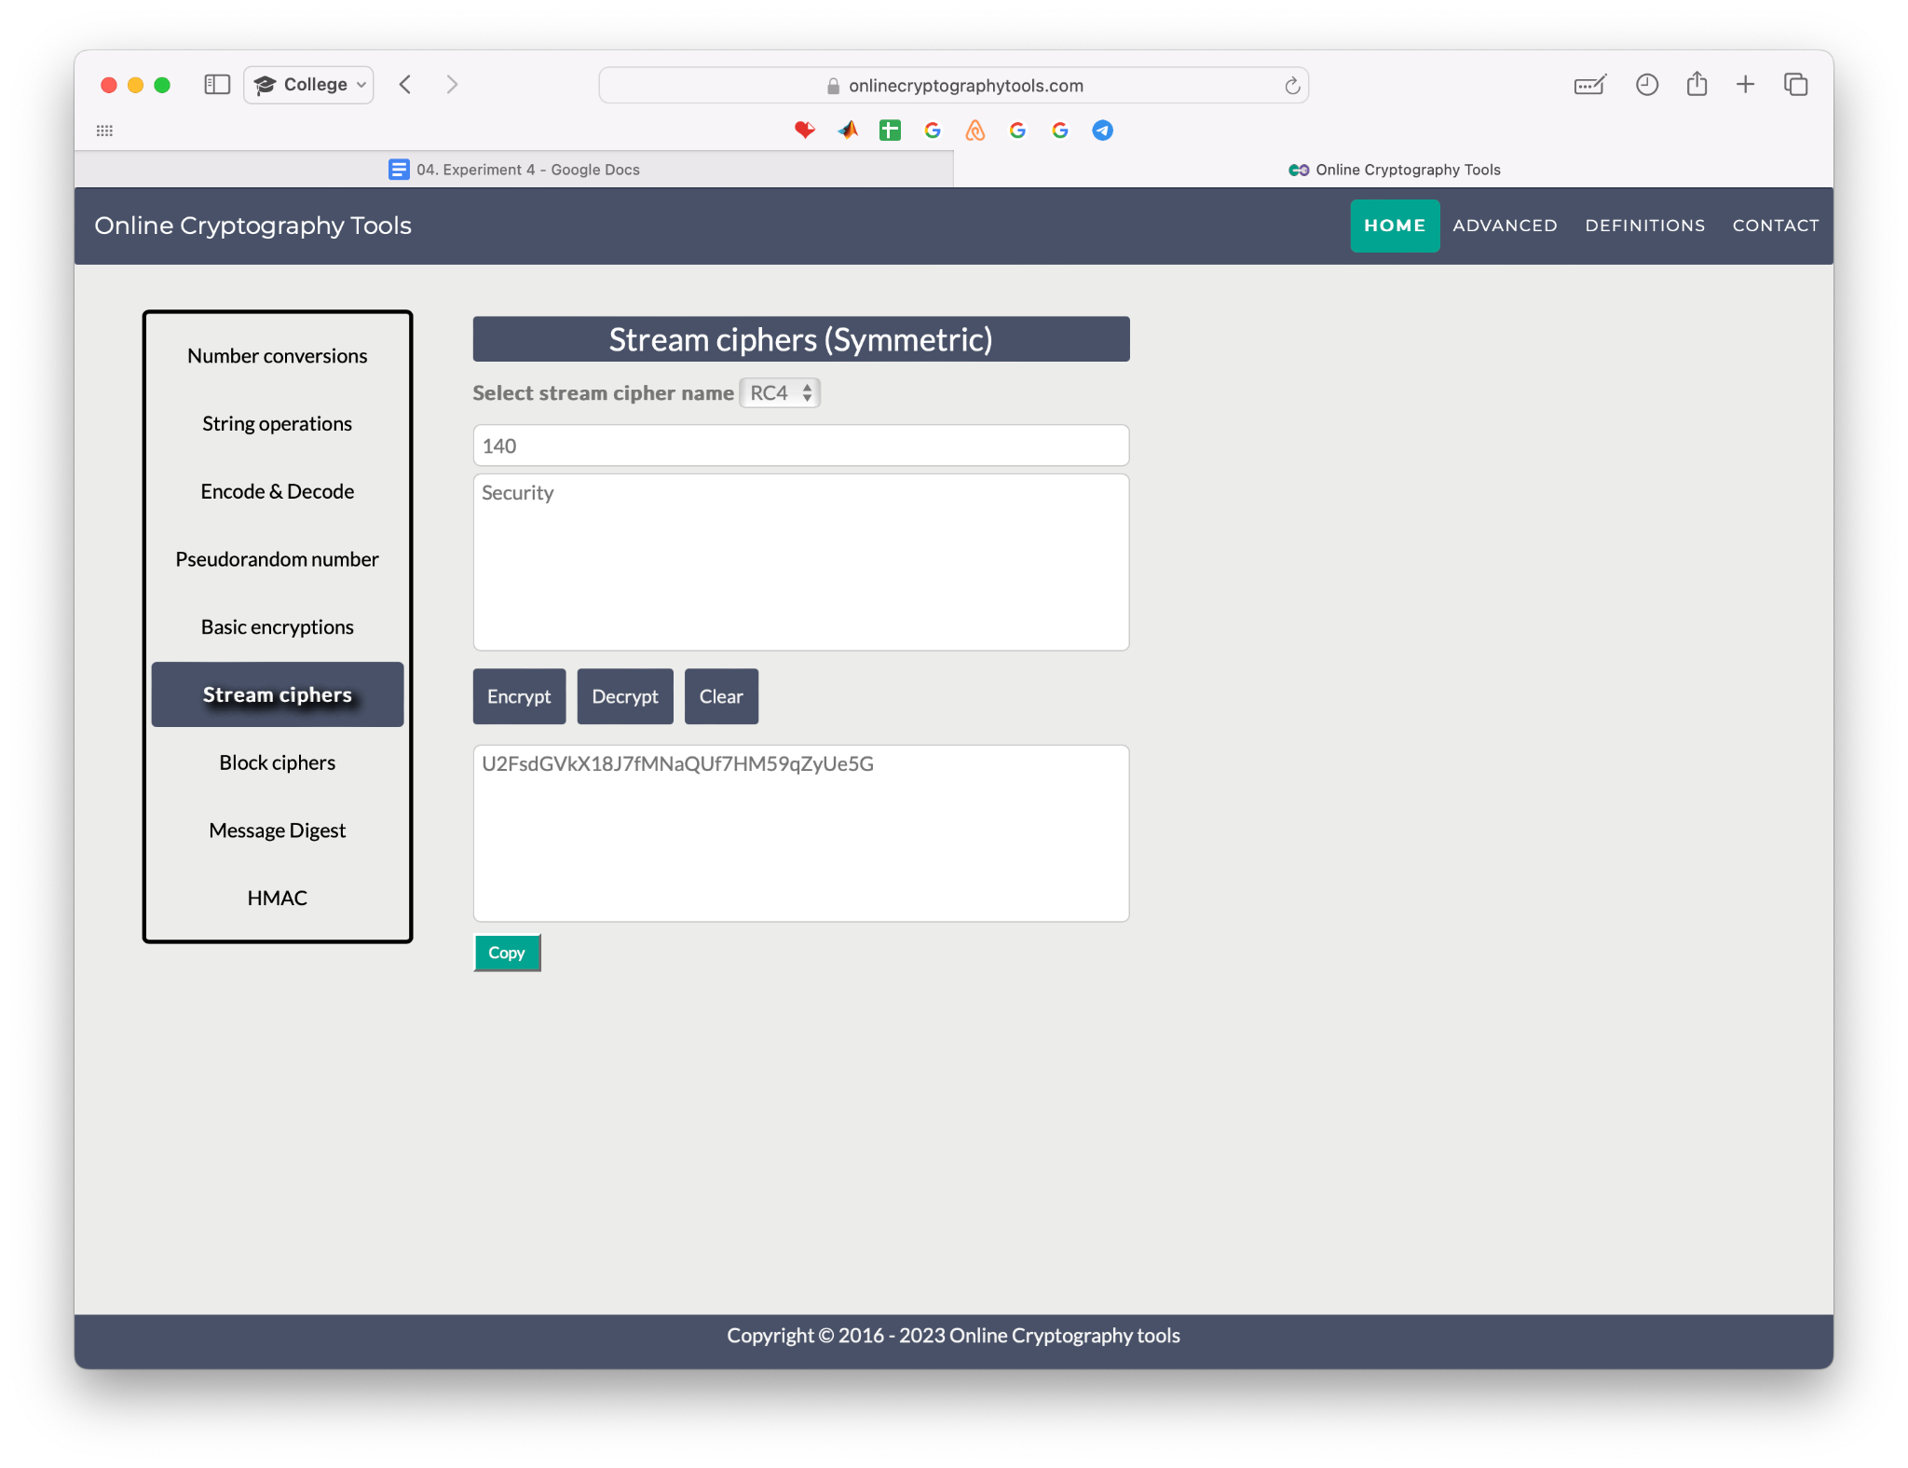

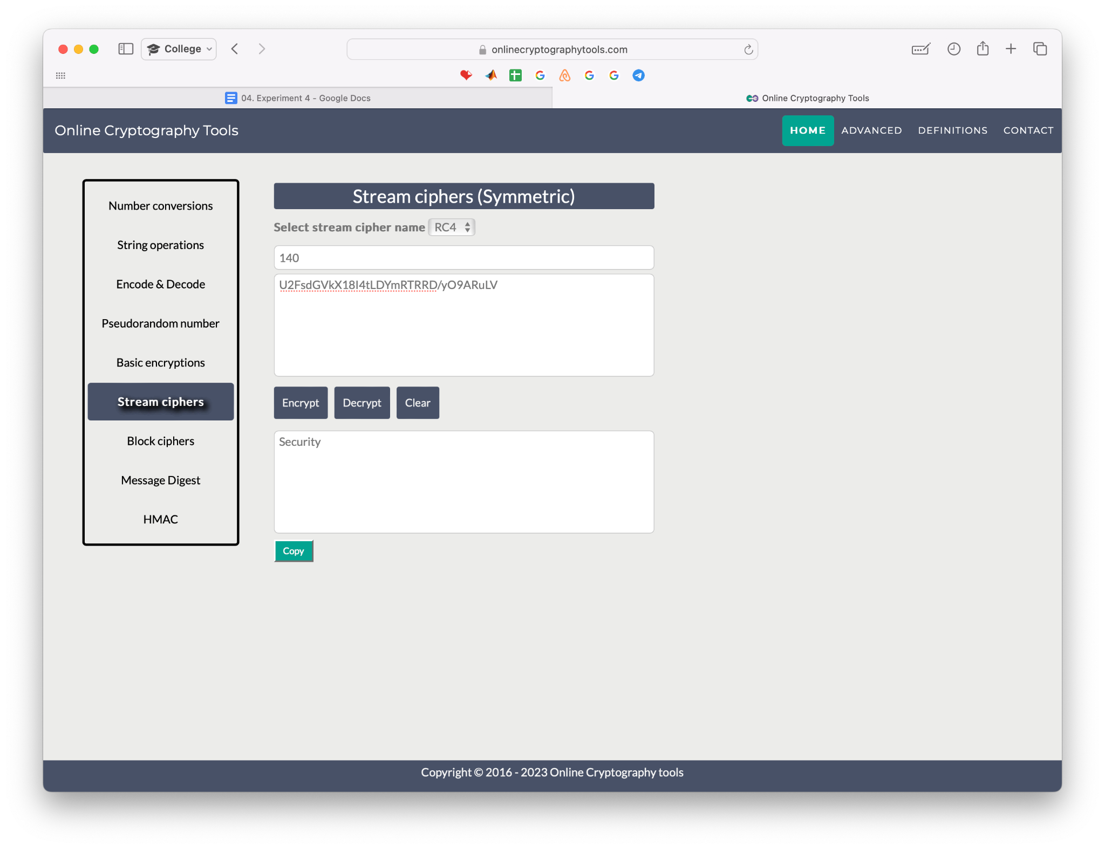

1. Perform 3 assignments from virtual lab based on stream cipher cryptography

* Breaking the Shift Cipher

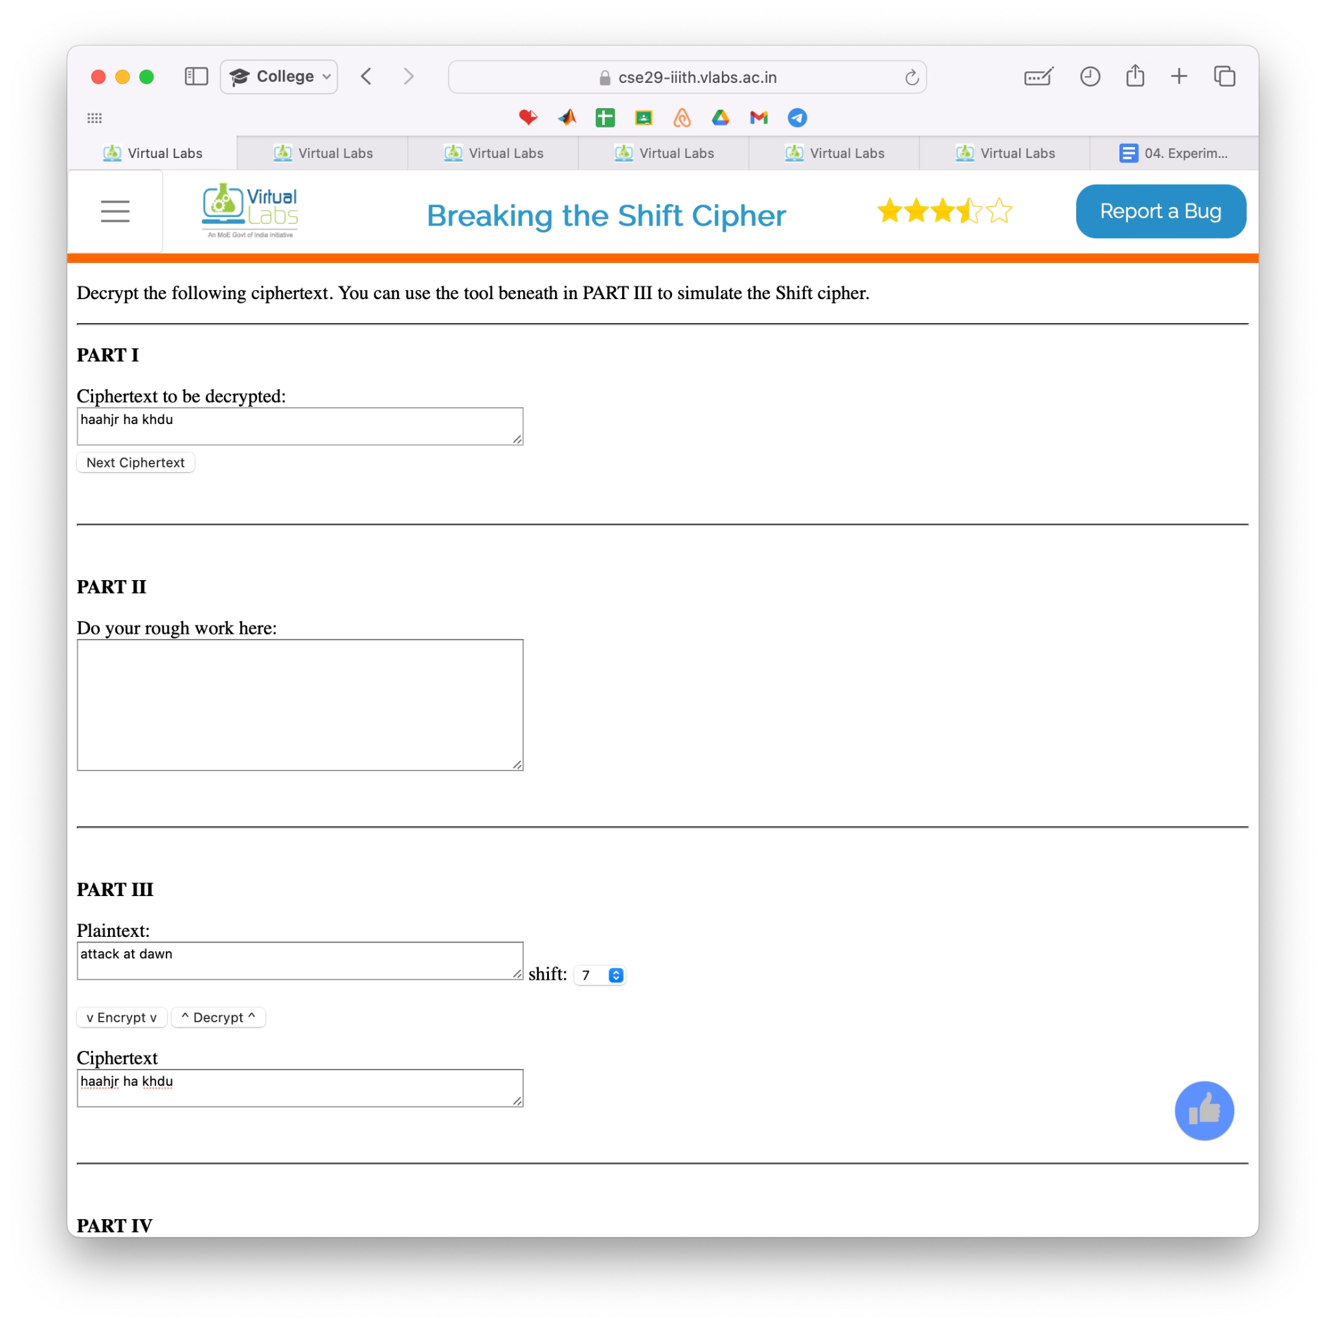

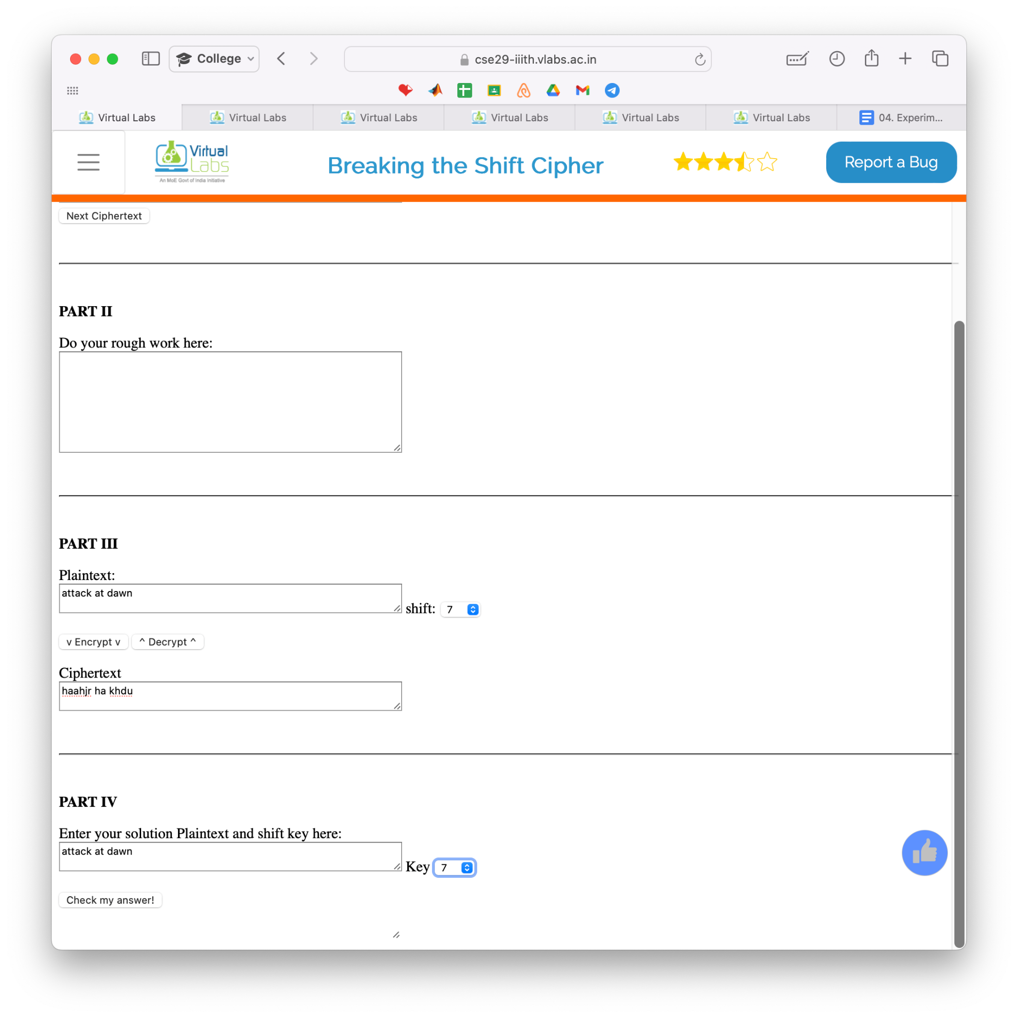

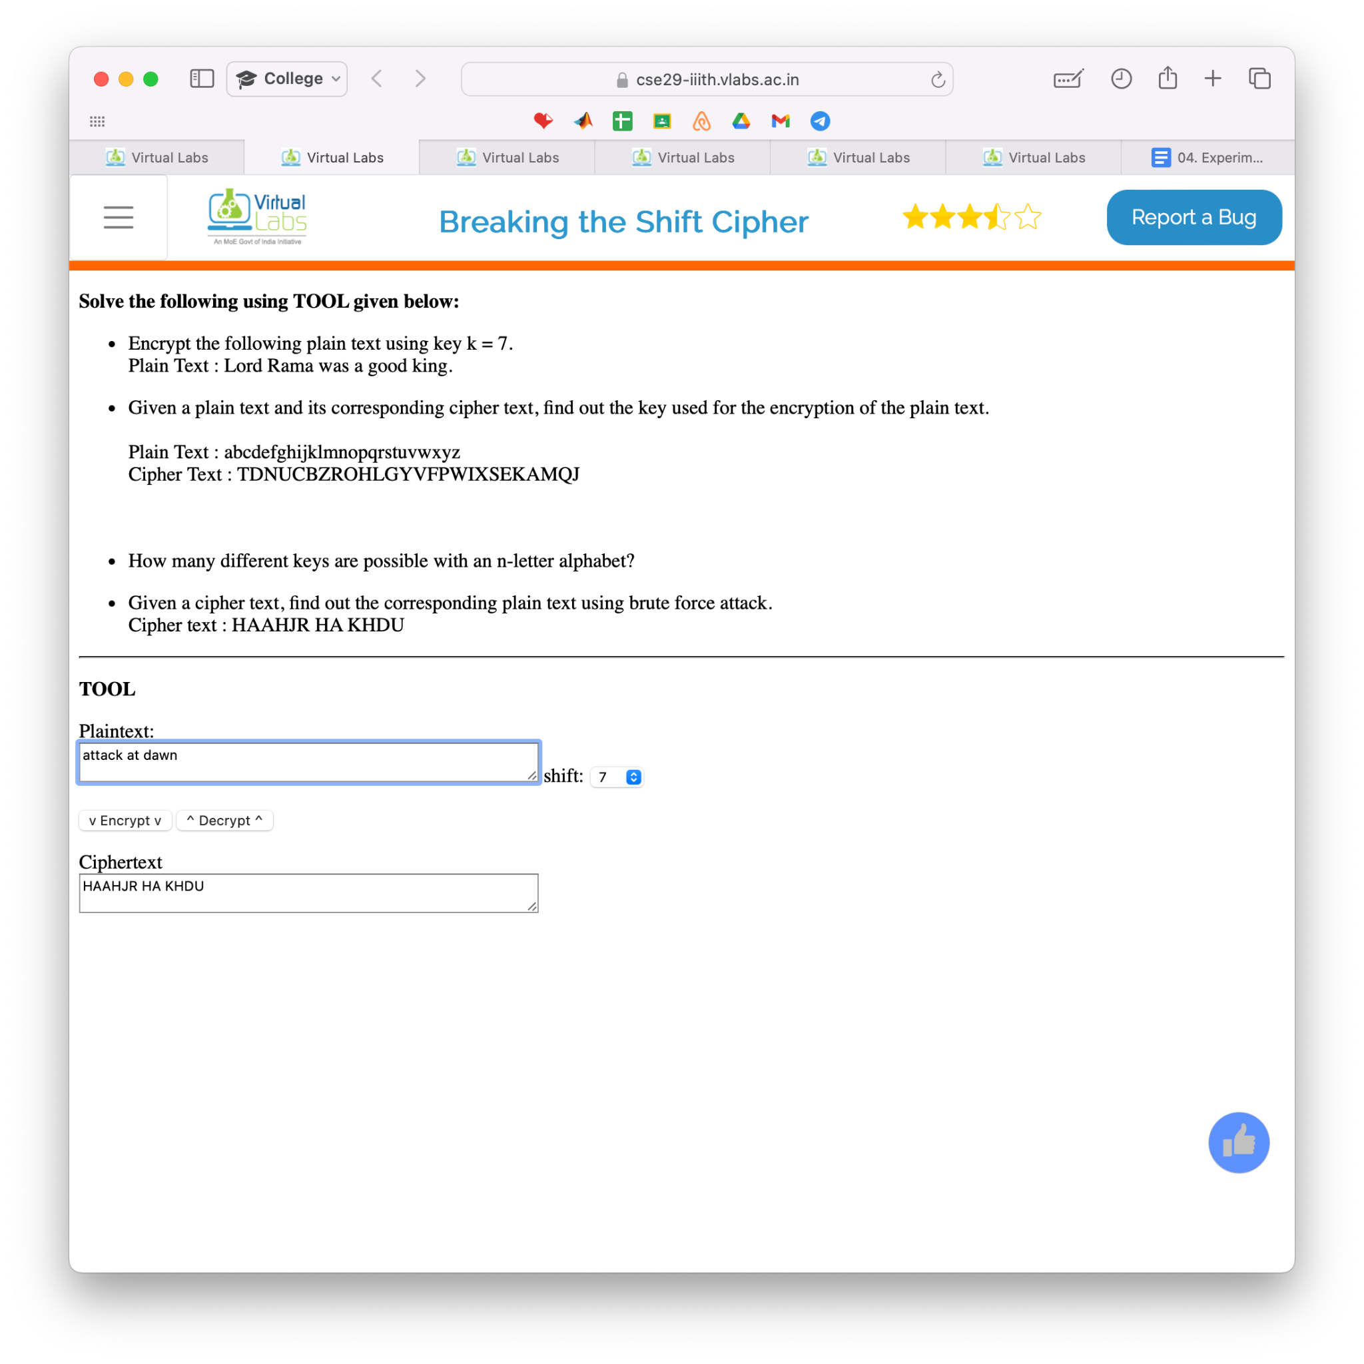

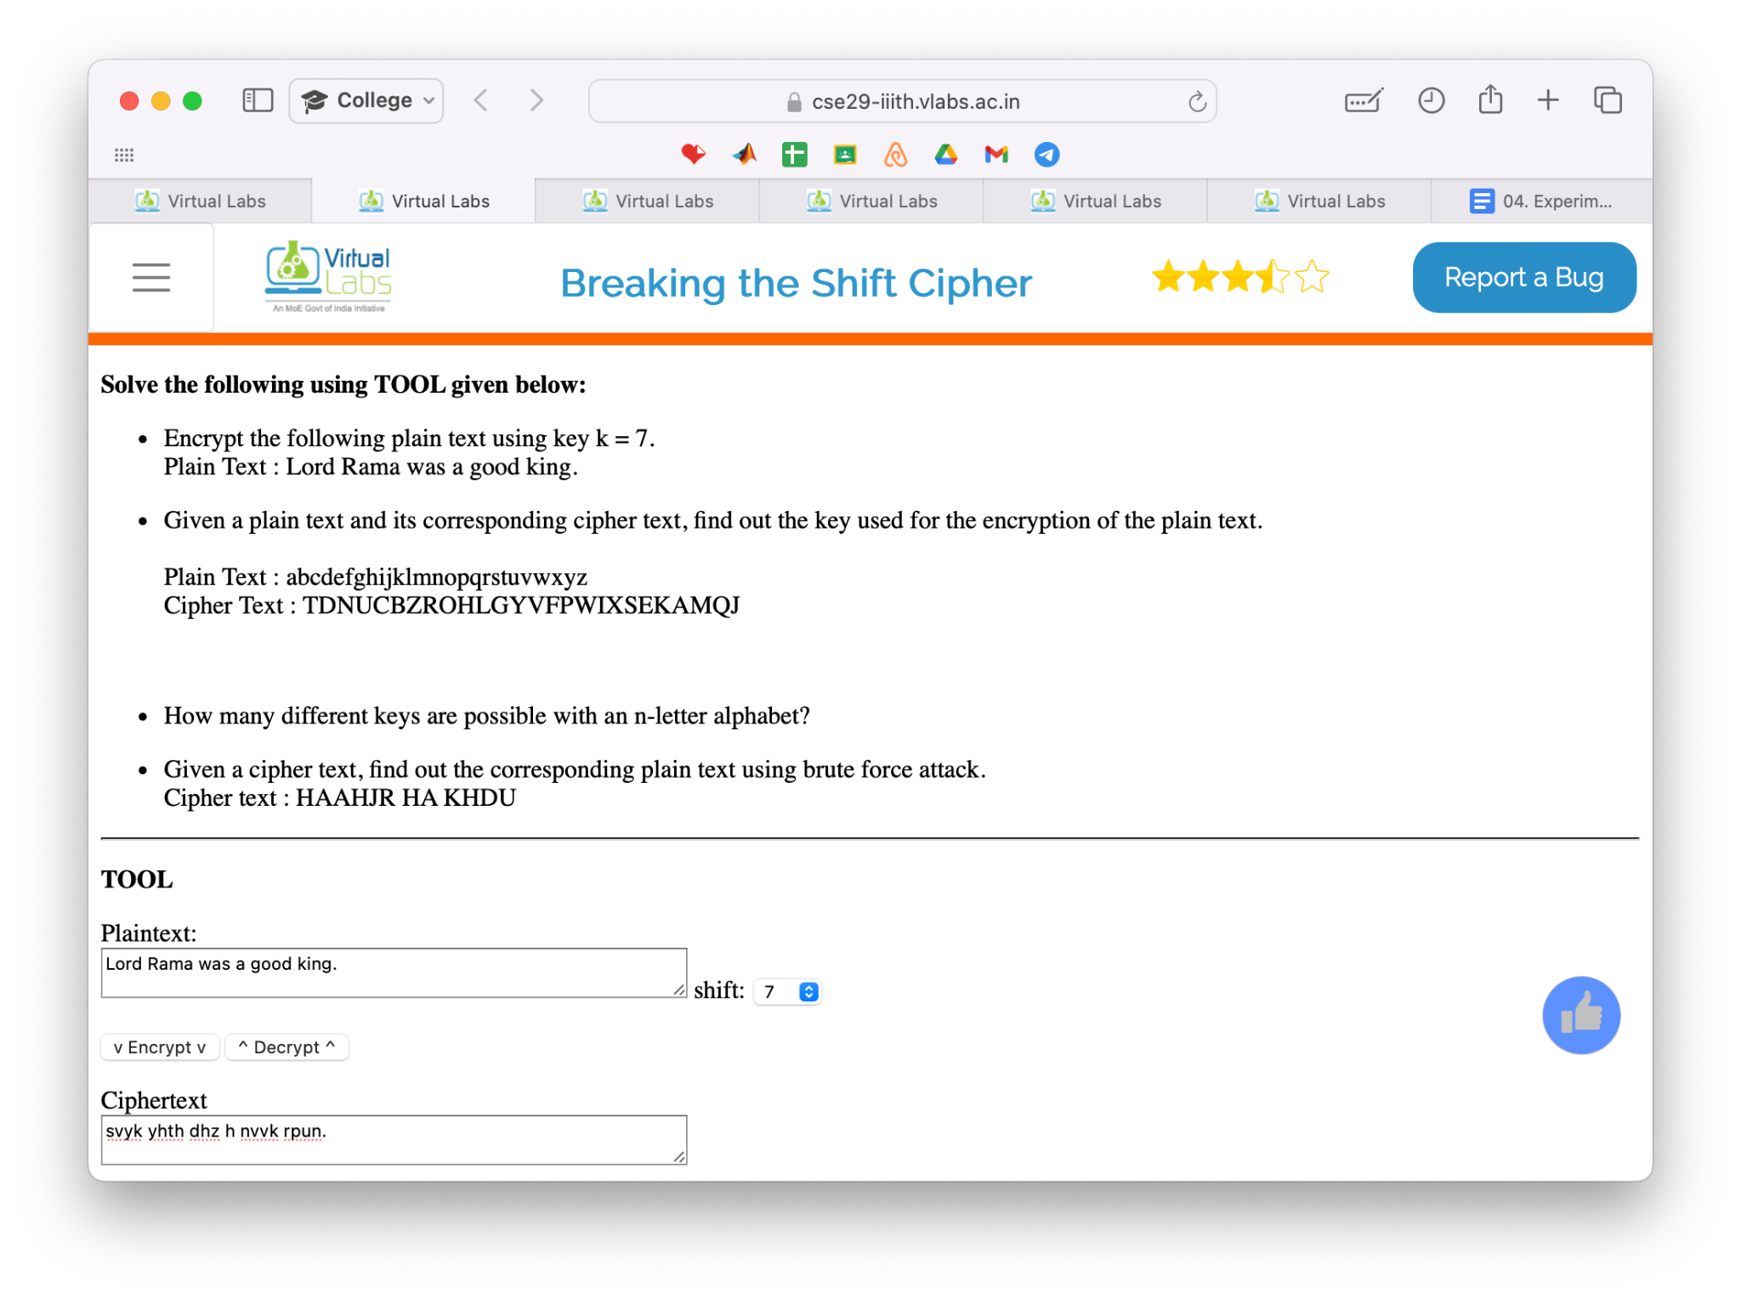

1. It isn’t possible using caesar cipher algorithm as the question is wrong
2. 26 Different Keys are possible with an n-letter alphabet



* Breaking the Mono-Alphabetic Substitution cipher

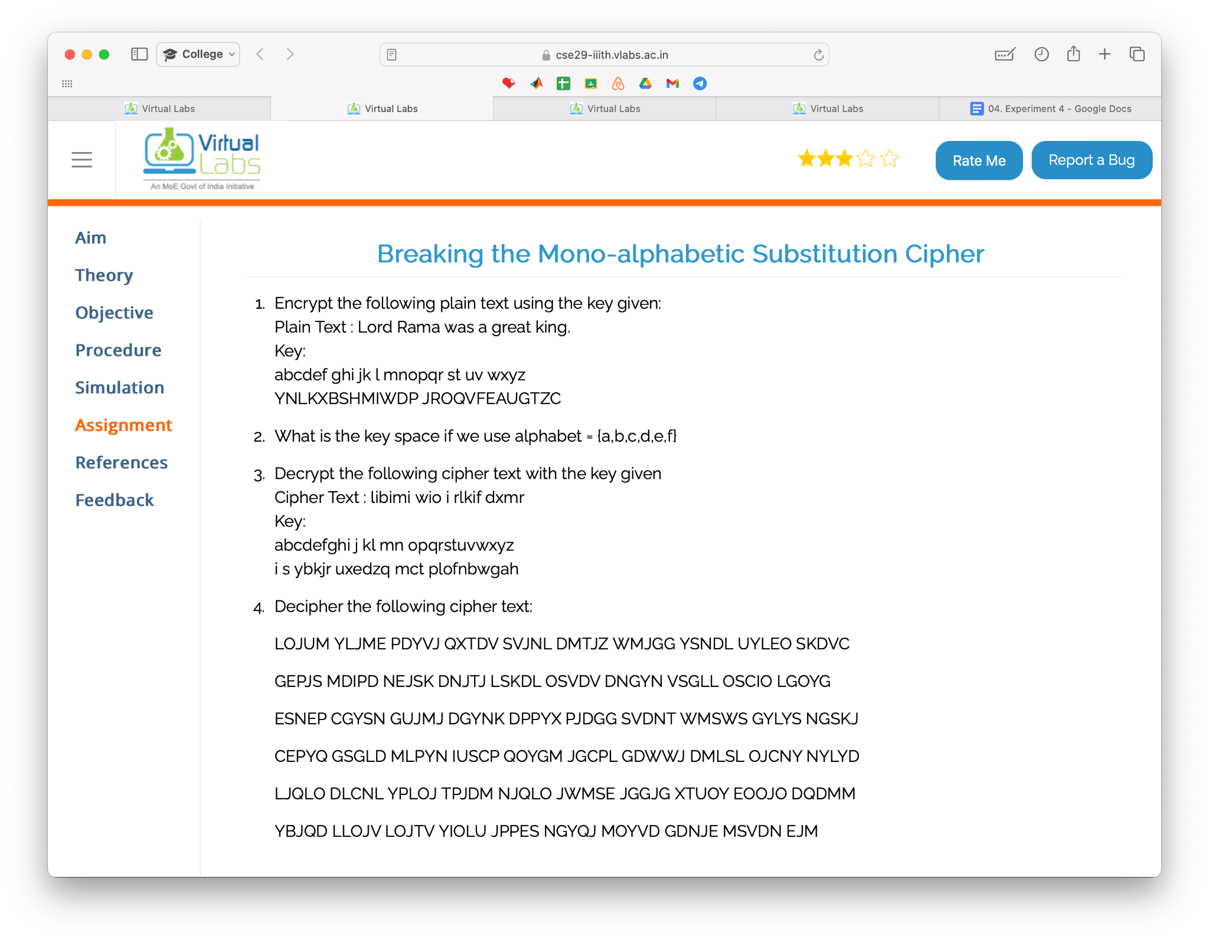

a.

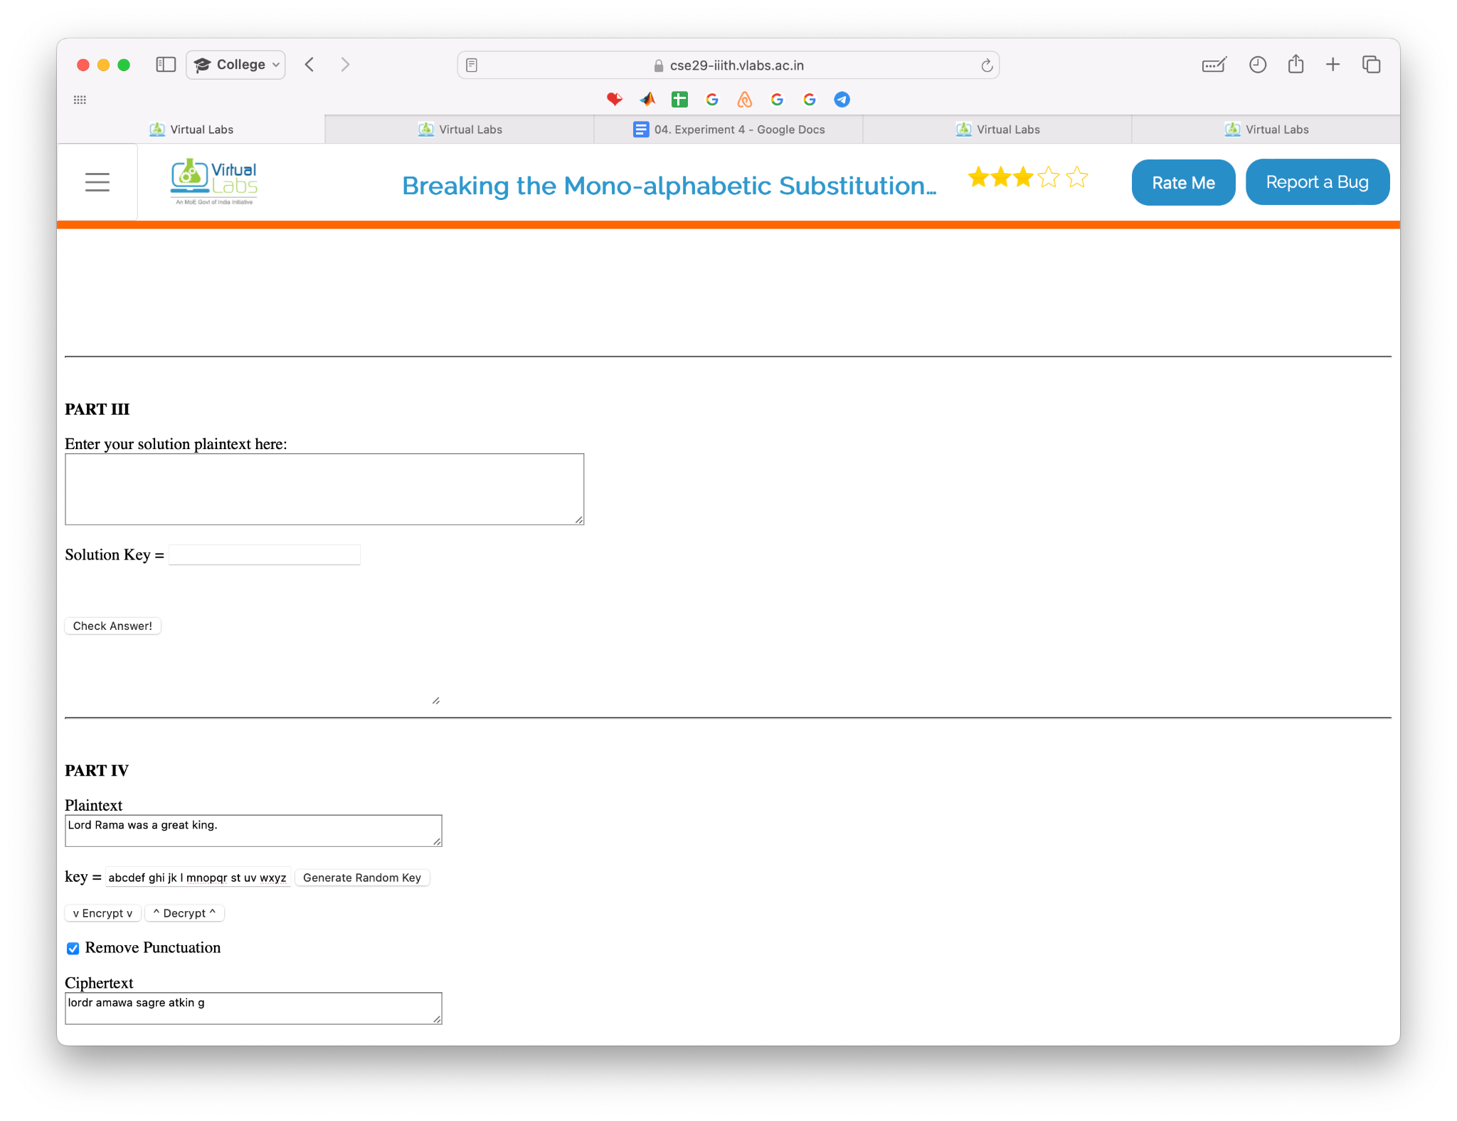

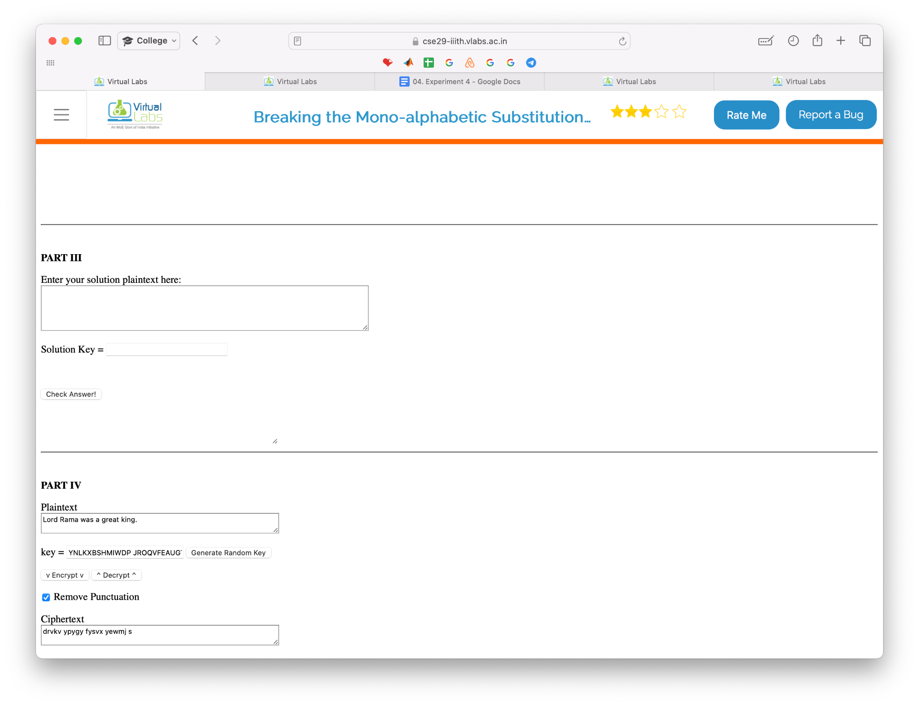

b. 6! = 720

c.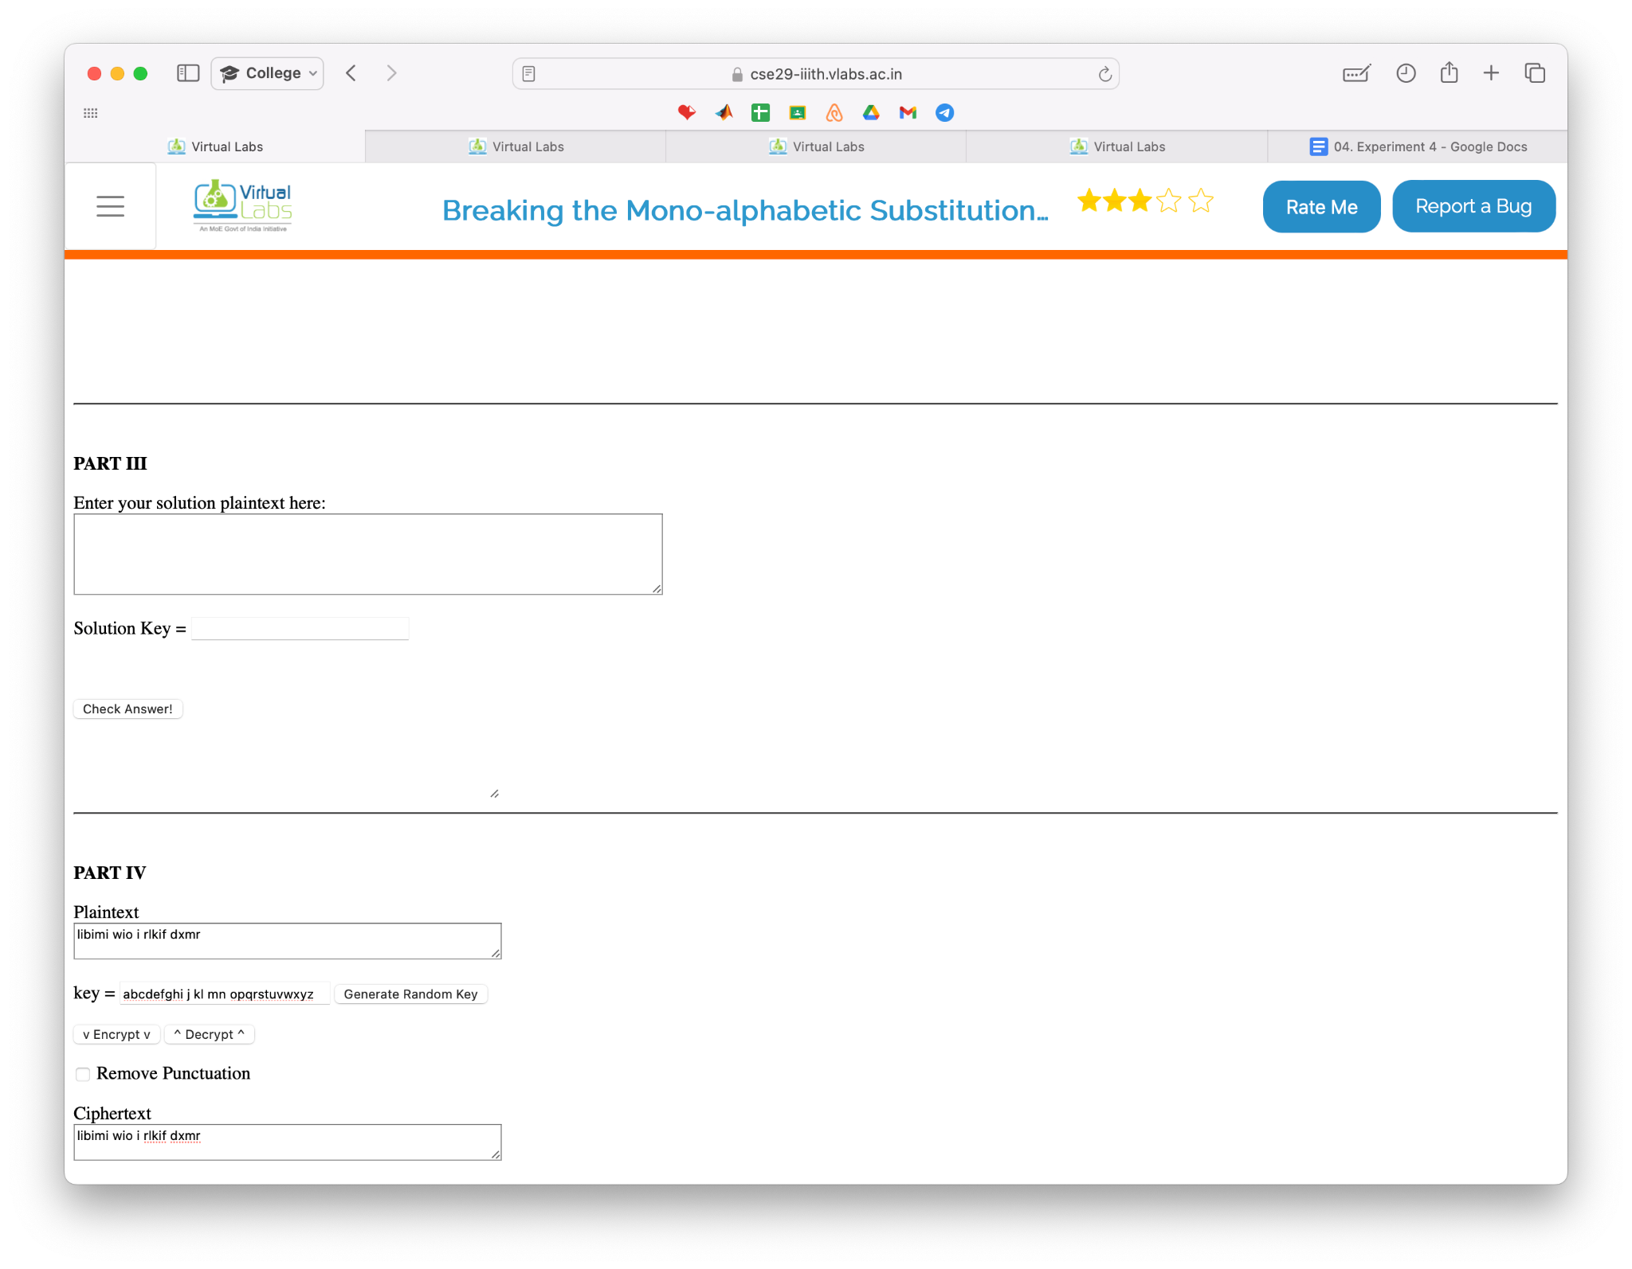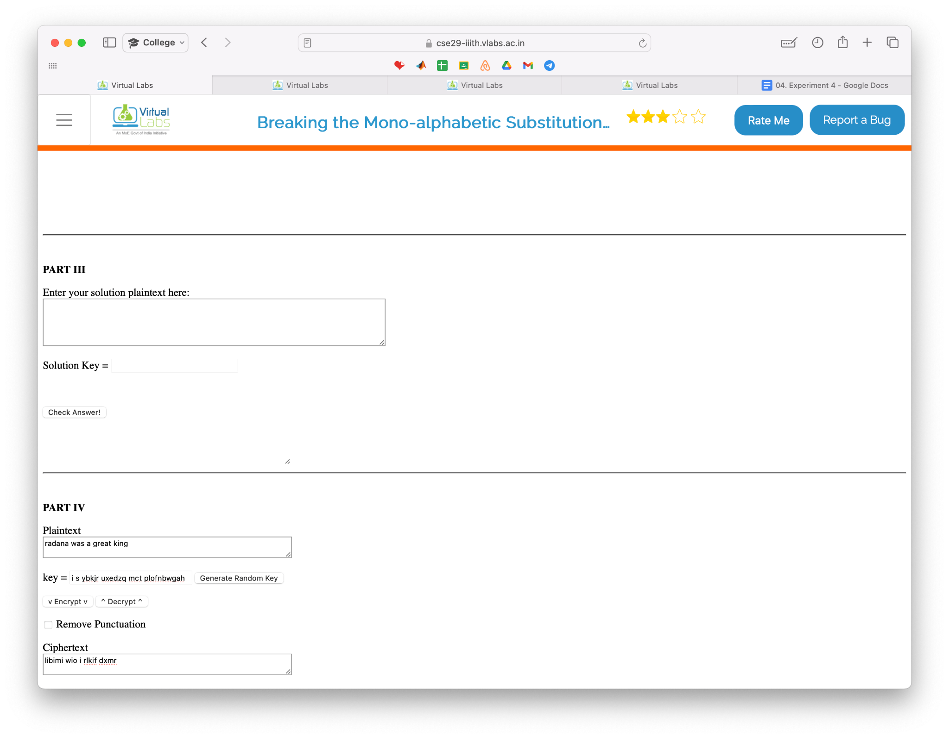

d. Not solvable using the provided tool

* Vernam Cipher & Perfect Secrecy

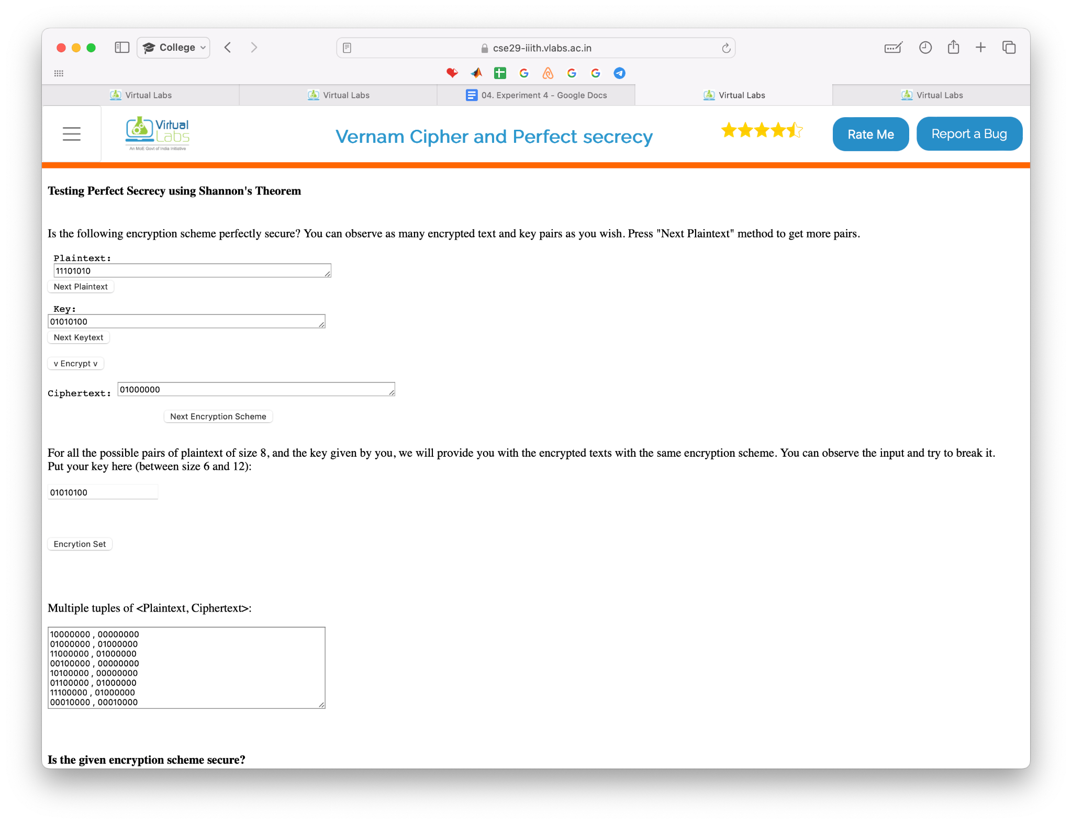

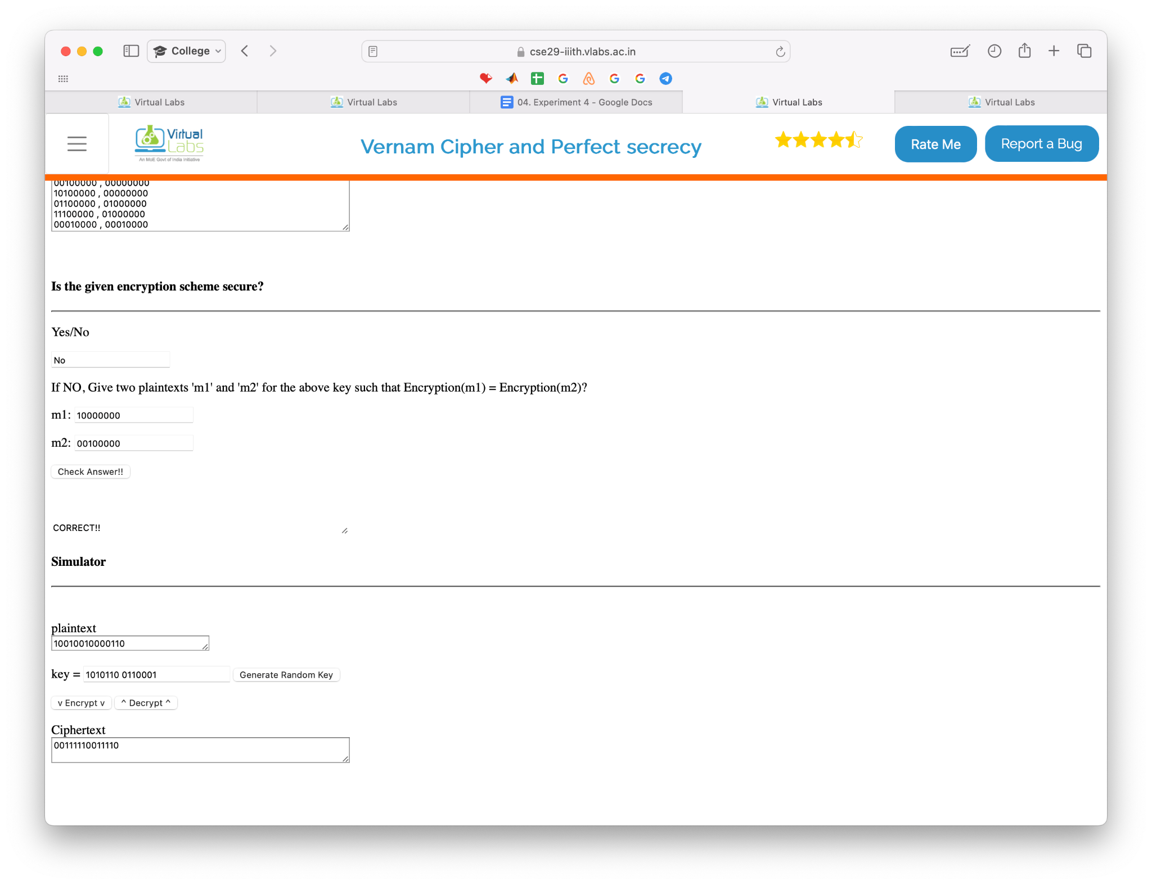

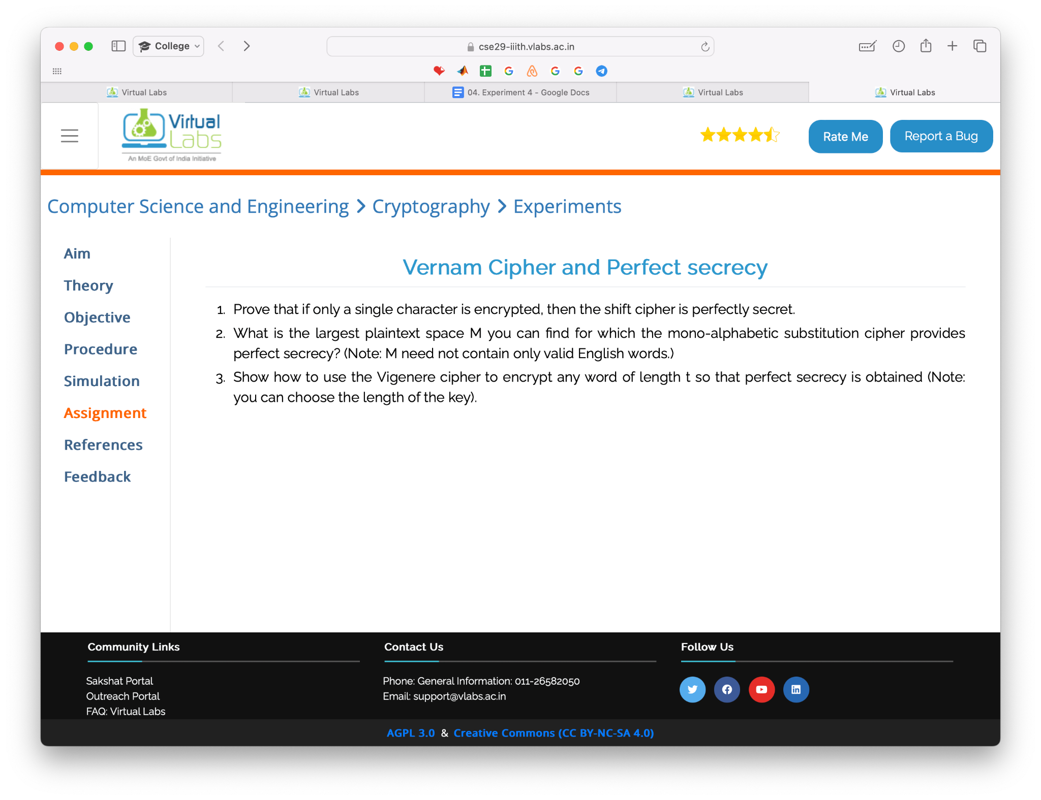

a.

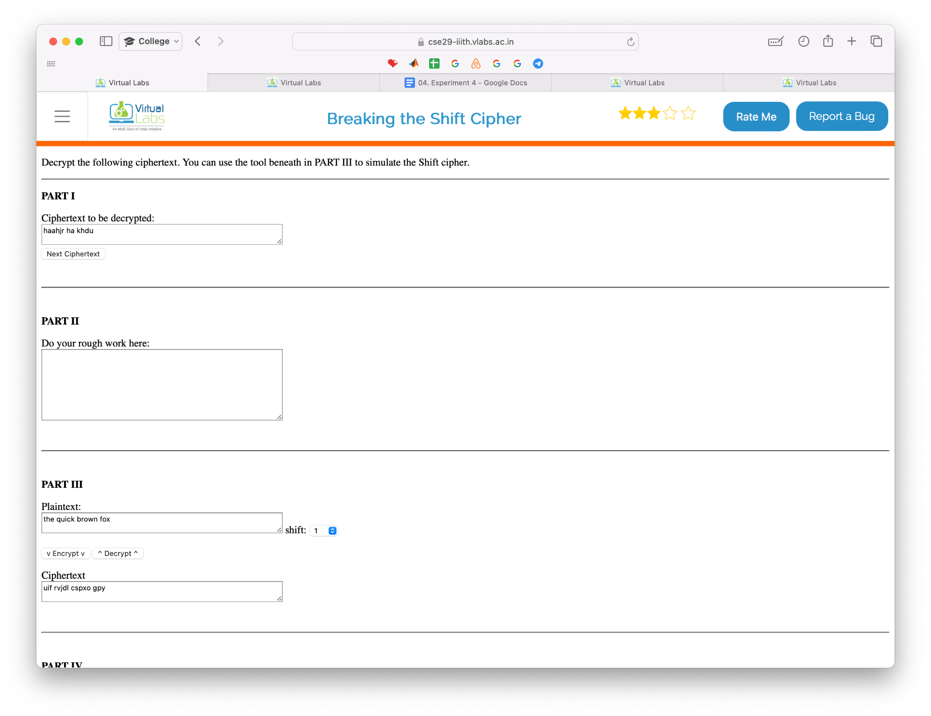

b. Not solvable using the provided tool

c. Not solvable using the provided tool

1. Write a program to perform a caesar cipher algorithm using Python or Java.

| # Caesar Cipher in Python  def caesar_cipher(text, shift):  result = ""    for char in text:   # Check if the character is an uppercase letter  if char.isupper():  position = ord(char) - ord('A')  new_position = (position + shift) % 26  new_char = chr(new_position + ord('A'))  result += new_char   # Check if the character is a lowercase letter  elif char.islower():  position = ord(char) - ord('a')  new_position = (position + shift) % 26  new_char = chr(new_position + ord('a'))  result += new_char    else:  result += char    return result  text = input("Enter the text to be encrypted: ") shift = int(input("Enter the shift value: "))  encrypted_text = caesar_cipher(text, shift)  print("Encrypted text:", encrypted_text) |
| --- |

**Output:**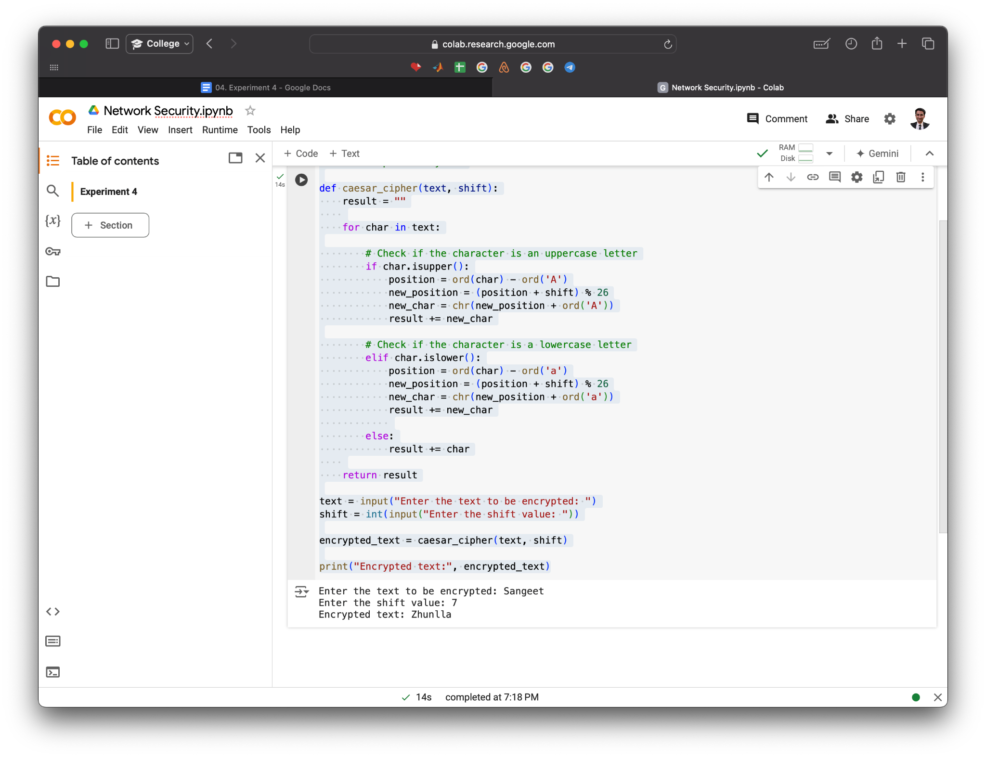

**Note:** Students are suggested to use Linux OS-based tools or free Windows OS based tools.